|  |
| --- |
| Sanna |

## Our award winning Sanna is a VW T6 conversion that is the ultimate in being an independent home on wheels. With two single seats in the rear and the option of making them into one double bed, this VW campervan includes a fixed cassette toilet, full kitchen, extensive storage and ample work surfaces, you really can go anywhere at anytime without the need for campsite facilities.

## Standard Conversion Features

* Jerba Campervans own rear elevating roof design with fully removable Ventile cotton canvas. Roof sprayed to match vehicle paintwork – max vehicle exterior closed height of 2 metres.
* 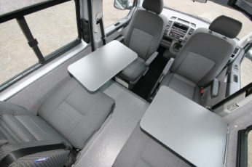Stainless steel SMEV 3 burner hob and combination sink unit with smoked glass top.
* Two 60cm wide rear seats/beds fully crash tested by Jerba Campervans to UK National Small Series Type Approval regulations. Two integral inertia seatbelts and two integrated headrests.
* Fixed Thetford C200 swivel bowl cassette toilet in rear offside corner with folding privacy door.
* Complete Sargent EC238 12 & 230v volt power system with Varta leisure battery located in rigid stainless steel cage on vehicle underside. All230v work tested and certificated by qualified electrical engineer.
* Full internal gas system with steel gas bottle locker with fully sealed door and one 3.9kg Calor propane cylinder. All gas work carried out by registered motorhome LPG fitter and certificated.
* 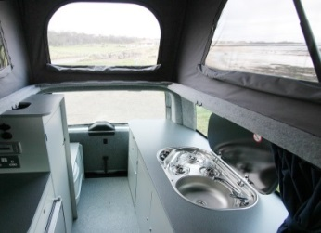Extensive cupboards and lockers and adjustable tables - all individually cut by finishing carpenters. Constructed from top quality lightweight 15mm poplar plywood with edge banded PVC trim finish.
* 38 litre fresh water tank located on the underside of the vehicle with water level gauge and Fiamma 7 litre/minute pump - all fittings drinking water quality approved.
* Vitrifrigo 12 volt low ampage 51 litre compressor fridge with 4 litre freezer box.
* All rear internal sides fully insulated with Non Itch recycled plastic bottle insulation and carpet lined with soft trim.

Optional Conversion Features

Include - hot blown heating, cool blowing fan, hot water and with optional shower, elevating roof double bed for two adults or children, soft thermoflex lining to rear seats and beds, double bed that’s also makes the two singles extra long at two metres in length, leather upholstery, safe box, flat glass plate diesel fuelled hob, grill or warming oven, cassette toilet, side window midge screens, waste water tank, solar panel, bike rack, awning rail, sunshade, roof rack, solid high top option and more!

Base Vehicle Specification & Price

All our new Volkswagen T6’s are equipped with a Euro 6 2.0 litre diesel engine and the starting price for our campervans is based upon the 102bhp version – we also include the excellent VW factory fitted swivelling front seats as standard. The new T6 also now includes Bluetooth mobile connectivity, digital radio with colour touchscreen and full Blue Motion Technology.

When placing an order with us we will help you through the Volkswagen factory options list, where you can choose from a wide range of items – from larger bhp engines, automatic and four wheel drive to rear parking sensors, a power latching slide door, airconditioning and much more!

Our starting price for the Sanna is £46,950 – this includes VAT, all Volkswagen delivery charges, number plates, our full standard specification and a full tank of fuel! Road tax is the only additional cost at £240.

#### Why Choose Jerba Campervans?

* We are an officially registered body builder and converter for Volkswagen
* Undertaken UK National Small Series Type Approval level safety crash testing
* Our furniture is individually built by us - we can make layout adjustments to suit you
* Our design & finish has been recognised through winning magazine industry awards
* On your DVLA ownership certificate all our campervans are classified as a Motorcaravan
* ISO9001- we have full accreditation for this international quality standard
* Our workshop is fully open to visitors - we have nothing to hide!

Daytime Layout

|  |  |  |  |  |  |  |
| --- | --- | --- | --- | --- | --- | --- |
|  |  | Swivelling driver and  passenger seats |  | Counter with drawer and  fridge beneath |  | Three burner hob with  combined sink |
|  | Tables |  | Full height wardrobe or  shelved cupboard |  | Full kitchen storage unit with ample counter space |
|  | Rear seats with belted  seating |  | Fixed cassette toilet |  |  |

Night Time Layout

|  |  |  |  |  |  |  |
| --- | --- | --- | --- | --- | --- | --- |
|  |  | Single beds with option  for double |  | Full height wardrobe or shelved cupboard |  | Three burner hob with combined sink |
|  | Counter with drawer and  fridge beneath |  | Fixed cassette toilet |  | Full kitchen storage unit with ample counter |

**“We also love how precisely Jerba’s furnishings are cut to fit: there are no nooks and gaps where you wouldn’t want them, such as between the kitchen unit and the van wall.”  
- Practical Motorhome**